|  |  |
| --- | --- |
| **Ex.No:04** | **Install Compliers to Execute Simple Programs** |
| **Date:** |

**Aim :**

To install a C compiler in the virtual machine created using virtual box and execute Simple Programs.

**Procedure**

**Step 1:-**

* Open created virtual environment (Ubuntu) using virtualbox.
* Select and click terminal application.
* Type the following command in the prompt to Install gcc compiler to run c programs.

**$sudo apt-get install gcc**

* The above command installed the complier.
* Enter the following command to type C program in the text editor,

**$gedit filename.c**

* The below shows the swap.c file typed in gedit text editor

**SOURCE CODE:**

#include<stdio.h>

int main() {

double first, second, temp;

printf("Enter first number: ");

scanf("%lf", &first);

printf("Enter second number: ");

scanf("%lf", &second);

temp = first;

first = second;

second = temp;

printf("\nAfter swapping, first number = %.2lf\n", first);

printf("After swapping, second number = %.2lf", second);

return 0;

}

* Type the following command to compile and run the file.

**$gcc filename.c**

**$./a.out**

**Example:**

**$gcc swap.c**

**$./a.out**

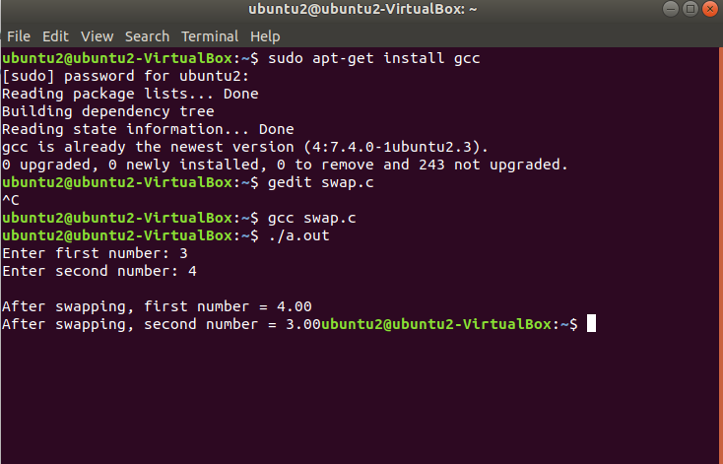

**Result:**

Thus the various compilers have been installed in Ubuntu and executed Simple Programs successfully.